Researchly: Research Paper Trend Mining Interpretation Document Report.

Table of Contents
Research Papers: Trend Mining AI 3
Project Overview 3
Section 1 3
Section 2 8
Section 3 10
Section 4 11

Research Papers: Trend Mining AI
Project Overview
Section 1
This project looks at research paper abstracts and asks the question: can a computer tell whether a paper uses ai methods or classical methods just by reading its abstracts.
The notebook has two parts:
- Classification (Section 1 and 2): A model learns to label an abstract as classical or AI.
- Summarization and topic discovery (Section 3 and 4) : Five full length research articles a summarized and grouped into themes.
2. The Data: The dataset contains 1,138 with three columns:
- DOI: The paper's unique identifier.
- Abstract: the paper summary text which is the main input for the models.
- Label: the answer either” classical “ or “ AI “
The classes are imbalanced. There are 900 classical papers (79%) and only 238 AI papers (21%). A lazy model that always says classical would already be right about 79% of the time, so accuracy alone is not a good measure of success.
3. Cleaning the data (Section 1)
Structural cleaning
The notebook first checks for missing values and duplicates. It found 4 missing DOI’s and 13 duplicate abstracts. The duplicates were removed because the same PayPal would otherwise land in both the training and testing sets. That could let the model “peak” add answers and inflate it scores. No duplicates had conflicting labels. The data set ended at 1125 abstracts.
Text Cleaning
Raw abstracts contain a lot of clutter. The audit found web links, LaTex maths, copyright notices, leading “Abstract” labels currently quotes and many digits. A denoise() Function cleans each abstract in these steps:
- standardize odd characters such as curly quotes and fancy dashes.
- Remove “Abstract:” or “Summary:” at the start
- Remove URL’s, DOIs and email addresses.
- Remove math’s written between $.....$.
- Remove copyright lines such as “Copyright © 2008 John Wiley & Sons”
- Convert to lowercase
- Keep letters only , which removes digits and punctuation.
- Remove very short words and stop-words( common words like”the” and “and”), as well as “paper”, “study” and approach” that appear in almost every abstract.
- Stem each word so “learning”, “learned” and “learns” all become “learn”
After cleaning the notebook checks that no URLs digits all copyright text remain. The vocabulary also shrinks a lot, which makes the problem easier for the model.
4. Exploring Features (Section 1.2)
Train/Test split
The data is split as 80% for the training (900 papers) and 20% for testing(225 papers). The split is stratified so both sit keep the same 21% share of AI papers.
Why DOI is not used as a feature
The DOI prefect identifies the publisher (for example, 10.1109 is IEEE and 10.48550 is arXiv)
The report found a clear link between publisher and label, meaning some publishers were mostly AI papers. The model would learn “which publisher” instead of “what the paper is about “DOI is excluded and the model learns from the abstract text only.
Do AI abstracts look different?
AI abstracts are somewhat longer. The difference is statistically significant, but the effect is small. The length alone cannot separate the classes, so the actual words matter more.
A chi-square test ranks words by how strongly they favour one class:
- AI side: network, machine learning, neural network, algorithm, LSTM , sentiment
- Classical side: policy, expectations, monetary, nominal, shock, uncertainty.
The classical words point to economics and finance, so the data set is likely finance and economics research. The AI method words are what the model learns on to spot on AI paper.

Visual: Top Chi-Squared Terms
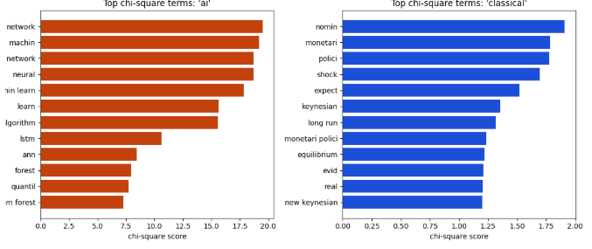
The bar chart shows the left chart (orange), which lists the 12 words most strongly tied to ai abstracts and the right chart (blue), which lists the 12 words most strongly tied to classical abstracts. Each bar is a word, and the longer the bar, the higher its chi-square score. A high score means the word shows up very differently between the two classes, so it is a good clue for telling them apart. The strongest word is at the top of each chart. The AI chart is dominated by method words such as “network”, “machine learning” and “neural network”. The classical chart is dominated by economics words such as “policy”, “monetary” and “nominal”. This confirms that abstracts can be separated by vocabulary, which is why a text-based model works here.
5. The Baseline Models (Section 1.3)
TF-IDF Turns each abstract into numbers. It gives higher weights towards that are distinctive and lower weight to words that appear everywhere. It uses single words and two-word pairs.
Logistic Regression uses those numbers to predict the label. It uses, (class_weight = “balanced”) so the smaller AI class is not ignored.
It is compared against a dummy model that always predicts the majority class.
Overfitting
On the training data the baseline scored a macro F1 of 0.98 against 0.82 on the test seat. The model memorizes some of the training data. Cross validation (5 fold) Gives a more honest estimate of about 0.86. The notebook also plots confusion matrix ROC curve, precision-recall curve and learning curve to show this visually.

Visual: The four-panel performance figure
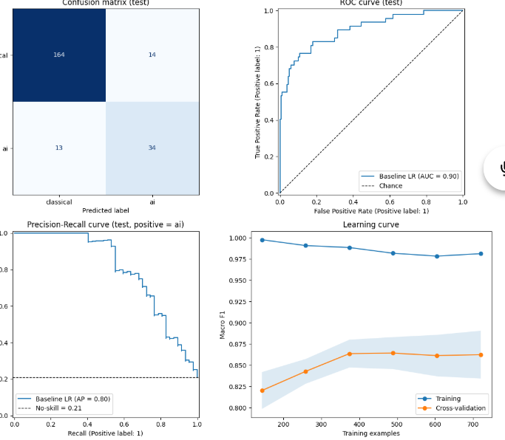
Confusion matrix (test): The cells in the diagonal represent the right predictions. The cells out of the diagonal were wrong predictions. The classification report shows that the baseline predicts correctly around 164 out of 178 classical papers and 34 out of 47 AI papers. Most errors were committed while predicting an AI paper as a classical paper with similar results in the reverse direction.
ROC curve (test): It considers true positive rate in relation to false positive rate when changing the threshold for decision making. The dashed diagonal line means pure chance. The greater the curve bows toward the upper left corner, the better the result is. The ROC-AUC rate of the calculated baseline is approximately equal to 0.90, meaning that when AI paper and classical paper are randomly selected the AI paper is scored higher in 90% of cases.
The precision-recall curve indicates how often “AI” prediction is correct when compared to the number of actual “AI” papers identified. The dotted horizontal line marks the “no skill” level (share of AI papers equal to about 0.21), while the precision-recall curve is significantly above it, implying that the model is indeed competent. This sort of visualization is particularly useful, as the ROC curve may not provide much information in datasets with unbalanced classes.
The learning curve shows the relationship between the number of training examples and macro F1. There are two lines, one for training score and one for validation score, along with a shaded area showing variation. In the case when the training score is higher than validation score, overfitting takes place, which can be seen above (0.98 vs 0.86). In case the validation line keeps increasing toward the right side, getting more data would be beneficial.

Section 2
Comparing Five Models
Five models were trained on identical features and compared using cross validation:
Model | CV Macro F1
Linear SVM | 0.889
Complement Naive Bayes | 0.867
Logistic Regression (baseline) | 0.862
Gradient Boosting | 0.854
Random Forest | 0.824

The best model is chosen using the cross validation and not the test set. The Linear SVM was considered the best model. Models like Random Forest and Gradient Boosting ( cmplex-tree- based models) did not do so well. Text data tend to suit linear models well compared to tree-based.
Visual : Model comparison bar chart
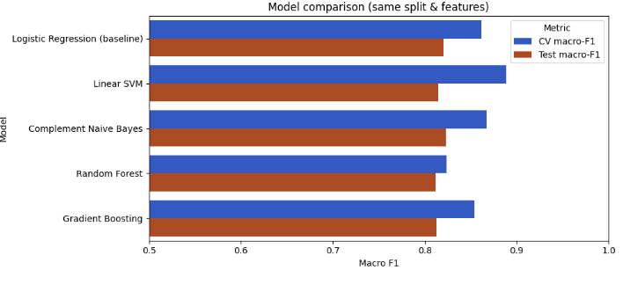
Improving the Model (Section 2,2)
A grid search tried different settings for the SVM and the TF-IDF step repeating the 5-fold cross validation 3 times for stable results. The best settings were C= 0.5, min_df = 5 and max_df =0.8 as well as the unigrams and bigrams.
However, the optimized SVM was unable to outperform the baseline model in the test set of 225 papers (F1 0.811 vs 0.820 for macro measure). This is explained in the notebook, as the test set is comprised of 47 AI papers and thus, the score can fluctuate up to ±0.03 between splits.

A more consistent evaluation:
In order to provide an accurate assessment, the system underwent 5-fold cross-validation performed 5 times (which resulted in 25 folds). Following that, a paired statistical analysis was done using Wilcoxon test:
Model | Mean Macro F1
Baseline LR | 0.846
Linear SVM (default) | 0.865
Linear SVM (tuned) | 0.864

Both SVM algorithms outperformed the baseline in most of the cases (18 and 20 out of 25 folds) showing improvement of around 0.02 (p < 0.001). Thus, SVM shows a modest yet consistently positive result. It should be noted that tuning did not considerably enhance performance of the SVM. The notebook indicates that tuning results in the tuned category might be overly positive as they were driven from the same dataset as a part of a solution.
The final Model (Section 2.3)
The last model combines the adjusted SVM and the denoise() method, allowing it to process abstracts independently. This is exactly what the web interface requires. The notebook then:
1. Verifies that the same testing score is achieved on unprocessed texts (0.811).
2. Trains it again on the entire volume of data, giving it more learning opportunities.
3. Saves it as researchly_model.joblib.
4. Conducts two smoke tests, predicting a statement about LSTM stock forecasting as ai and a one about New Keynesian monetary policy as classical.

Section 3
Summarizing Articles(Section 3)
The loading of the five text files goes into a data frame.
Denoise() takes care of the lowercasing of words, though it also eliminates everything that is written in brackets and keeps only letters while discarding common words.
Summary of the first article: The text is divided into sentences after which all of the sentences get the TF-IDF score and the three sentences with the highest scores make up the summary. This is called extractive summarization, as it does not produce any new sentence but only uses the ones already in the text. A bar graph shows the most important words.
Summary of articles: The rest of the texts are cleaned and subjected to LDA method to extract common themes. The graph shows the major keywords.
Visual: Aggregate Keywords across articles
The bar graph shown in section 3.4 demonstrates that the taller the bar, is the more important term for the whole group of articles. The labels are rotated to fit. It also gives a general overview of the shared vocabulary used in the study.
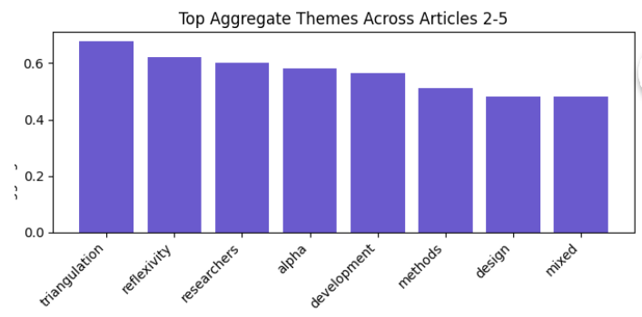

Section 4
Topic Modelling with LDA(Section 4)
LDA (Latent Dirichlet Allocation) is a computer program that identifies the presence of hidden topics in a collection of documents. It assumes every document is a combination of different topics, and any topic consists of several words. It executed in this example with respect to 3 topics across five manuscripts.
Topic | Top words | Theme
1 | development, methods, researchers, mixed, quantitative, instructional | Mixed-methods and instructional development research
2 | alpha, instrument, reliability, Cronbach’s, items, education | Measuring reliability of survey instruments
3 | triangulation, reflexivity, researcher, multiple | Qualitative research validity

Almost every document consists nearly wholly of one particular topic (over 99.9% of the text). Articles 1 and 3 were classified as Topic 1, article 4 belongs to Topic 2, while articles 2 and 5 are classified as Topic 3. The point is that topics are well-separated due to the fact that the number of documents is relatively small. After that, there is a pyLDAvis visualization featuring a number of circles representing topics.

